ESO204A- Fluid Mechanics and rate process
Tutorial 4
All problem nos. are corresponding to 7th edition of the book.
- P3.60
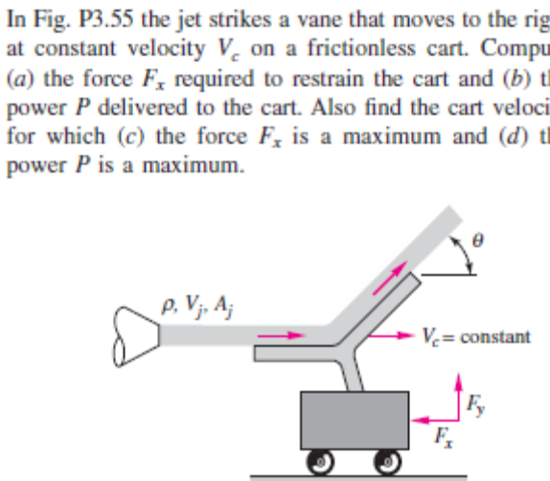

- P3.68
- 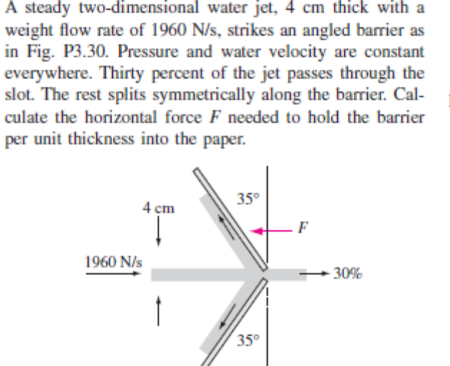
P3.84

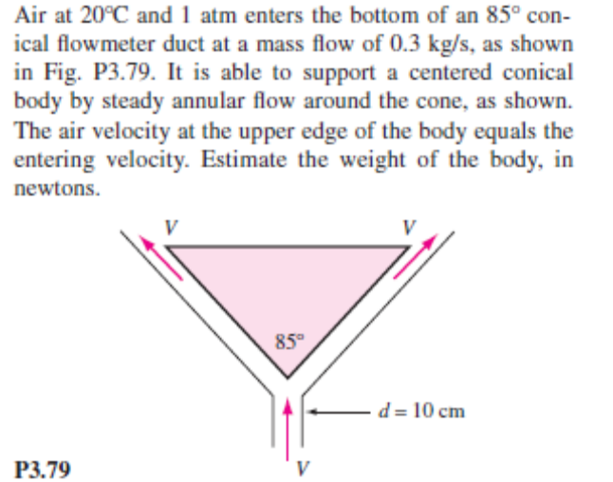
- P3.119

